

UPPP: A Community-Based Link Sharing Platform

A Final Project in partial fulfillment of the requirements for the course ITE 206L- Fundamentals of Database Systems.
Presented to the Faculty of the College of Information Technology
Franciscan College of the Immaculate Conception, Baybay City, Leyte Incorporated

Juris V. De Vega
Rica Ana C. Fernandez
James Carl R. Sitsit
Jan Marco C. Uy

APRIL 2026
APPROVAL SHEET

This project titled “UPPP: A Community-Based Link Sharing Platform” prepared and submitted by Juris V. De Vega, Rica Ana C. Fernandez, James Carl R. Sitsit and Jan Marco C. Uy in partial fulfillment of the COURSE ITE 206L: FUNDAMENTALS OF DATABASE SYSTEMS has been recommended for acceptance and approval for ORAL PRESENTATION.

JILL ZARAH B. SABANDO, MIT
Instructor, ITE 206L

EVALUATOR

________________________ __________________________

___________________________________

________________________________________________________________________
PANEL OF EXAMINERS
Approved by the Committee on Oral Presentation with a grade of ______.

________________________ __________________________

___________________________________

ACCEPTED and APPROVED in partial fulfillment of the requirements for the course ITE 206L: FUNDAMENTALS OF DATABASE SYSTEMS
BIOGRAPHICAL DATA
Juris Valdesco De Vega, 21 years old, was born on February 18, 2005, in Caloocan City. He is currently pursuing a Bachelor of Science in Information Technology at the Franciscan College of the Immaculate Conception. He completed his senior high school education at the same institution, specializing in the Information and Communications Technology (ICT) strand.
Throughout his academic journey, he has demonstrated strong dedication to his studies and technical projects. He is keen to learn various software and technologies to further enhance his skills and knowledge, continuously challenging himself to grow and prepare for future professional opportunities.
Rica Ana Cortejos Fernandez was born in 1996 in Baybay City, Leyte, Philippines. She is currently pursuing a Bachelor of Science in Information Technology at the Franciscan College of the Immaculate Conception.
She completed her elementary education at Bitanhuan Elementary School and her secondary education at the Franciscan College of the Immaculate Conception, where she cultivated a strong interest in technology and information systems.
Throughout her academic journey, Rica has demonstrated dedication, curiosity, and a commitment to learning, particularly in programming, software development, and IT-related projects. She continues to develop her skills in preparation for future professional opportunities in the field of information technology.
James Carl Redelosa Sitsit, a 20-year-old student currently residing at Zone 16, Baybay City, Leyte, is in his second year pursuing a degree in Information Technology, a field that allows him to explore his deep-seated interests in the digital world. Outside of his academic coursework, his primary hobbies include game development, video editing, and drawing. Throughout his journey, he has achieved milestones such as absorption in an IT company and building applications, which have helped shape his dedication to technology and problem-solving. As he continues his education, he looks forward to further developing his technical skills and finding new ways to bring creative digital ideas to life.
Jan Marco Cala Uy is a 21-year-old resident of San Pedro D Veloso St., Baybay City, Leyte, Philippines. His hobbies included art in different mediums such as digital and traditional, engages gaming activities mostly digital and board games, and working out inside of local gyms. He is currently an IT student at FCIC, having previously studied at an art school, and spent most of his time in FCIC, from elementary to college. Throughout his educational journey, he has achieved notable accomplishments such as winning an art contest at FCIC and displaying a finished painting in a local market.

Table of Contents
Chapter I....................................................................................................................... 1
Introduction.................................................................................................................. 1
Project Context .......................................................................................................... 1
Objectives.................................................................................................................. 2
Description of the proposed system.......................................................................... 2
Scope and Limitation ................................................................................................ 3
Scope...................................................................................................................... 3
Limitations............................................................................................................. 4
Chapter II...................................................................................................................... 5
Database Design........................................................................................................... 5
Entity Relationship Diagram .................................................................................... 5
Data Schema.............................................................................................................. 6
Database Dictionary...................................................................................................... 7
Chapter III .................................................................................................................. 11
CRUD Implementation ........................................................................................... 11
Create................................................................................................................... 11
Read (Display)..................................................................................................... 14
Update (Edit)........................................................................................................ 16
Delete (Remove) .................................................................................................. 19
Security Measures ................................................................................................... 20
Error handling......................................................................................................... 21
Chapter IV................................................................................................................... 23
USER MANUAL......................................................................................................... 23
References................................................................................................................... 34

Chapter I
Introduction

Project Context
The internet has grown into a massive collection of websites, tools, and resources. However, finding high-quality and useful links can be difficult because there is no single place where people can share and organize them together. Most search engines return too many results, making it hard to find what is truly useful and community recommended.
This project, called UPPP, is a web-based community link-sharing platform that allows registered users to submit, discover, and vote on useful links. The system was developed as part of the requirements for ITE 206L – Fundamentals of Database Systems, with a focus on applying relational database concepts in a real-world web application.
UPPP uses PHP as its server-side programming language, MySQL as its database management system, and XAMPP as its local development server. The platform allows users to submit URLs along with a title and description, vote on submissions, leave comments, and organize content by category. An administrator panel is also included for content moderation and user management.
The name UPPP is inspired by the concept of upvoting — a common feature in community-driven platforms where users decide what content is valuable by voting it up or down. The platform promotes a collaborative approach to content curation, where the community itself determines what is worth sharing.

Objectives
The main objective of the system is to provide an organized and secure platform for community members to share, discover, and interact with useful online resources.
Specific Objectives
- To design and implement a relational database that efficiently supports the link-sharing platform.
- To apply CRUD (Create, Read, Update, Delete) operations using PHP and MySQL with PDO prepared statements.
- To implement user authentication, session management, and role-based access control for both regular users and administrators.
- To ensure security by applying best practices such as input validation, CSRF protection, password hashing, and XSS prevention.
- To develop a content moderation system that allows administrators to manage submissions, users, reports, and categories effectively.
- To provide a user-friendly interface that enables community members to submit, discover, vote on, and discuss online resources.
Description of the proposed system
The system, called UPPP, is a web-based application that runs on a local XAMPP server using Apache and MySQL. It is developed using plain PHP and follows a page-based routing structure, where each feature is implemented as a standalone PHP file. No external frameworks are used, making the codebase simple, accessible, and easy to understand.
UPPP supports two types of users: regular users and administrators. Regular users can register an account, log in, submit links, vote on submissions, leave comments, search for content, browse by category, edit their profile, and report inappropriate content. Administrators have access to a dedicated admin panel, allowing them to approve or reject submitted links, manage user accounts, resolve reports, and manage content categories.
All submitted links go through a moderation workflow. Links are initially saved with a “pending” status and only become publicly visible after approval by an administrator. Rejected submissions are visible only to the submitter and the administrator, ensuring that all public content has been reviewed.
The voting system allows users to upvote or downvote approved submissions. Votes are toggleable: clicking the same vote again removes it, while clicking the opposite vote switches it. The homepage features a “Top of the Week” section that ranks recent submissions using a formula that combines net vote score with a recency bonus over seven days.
Additional features include a comment section on each submission’s detail page, a search function that scans titles, descriptions, and URLs, and a user profile page where individuals can view their submission history and update their bio, avatar, and website link.
Scope and Limitation
Scope
The system includes the following features:
• User registration, login, and logout with session management.
• Link submission with title, URL, description, and category.
• Admin moderation workflow with pending, approved, and rejected statuses for submissions.
• Upvoting and downvoting of approved submissions via AJAX.
• Commenting on submission detail pages.
• Category browsing and full-text search across titles, descriptions, and URLs.
• User profile pages with bio, avatar upload, and website link.
• Content reporting system for submissions and comments.
• Admin panel for managing submissions, users, categories, and reports.
• Pagination on all list pages.
Limitation
The current version of the system does not include the following features:
• Email verification upon registration — accounts are activated immediately without email confirmation.
• Real-time features such as live notifications or live updates to vote counts without page refresh.
• Mobile application — the system is only accessible through a web browser.
• Deployment on a public server — the system runs only on a local XAMPP installation.
• Rate limiting — there is no protection against automated or repeated form submissions.
• Nested comments or reply threads — comments are flat and non-threaded.
• Password reset functionality via email.

Chapter II
Database Design

Entity Relationship Diagram
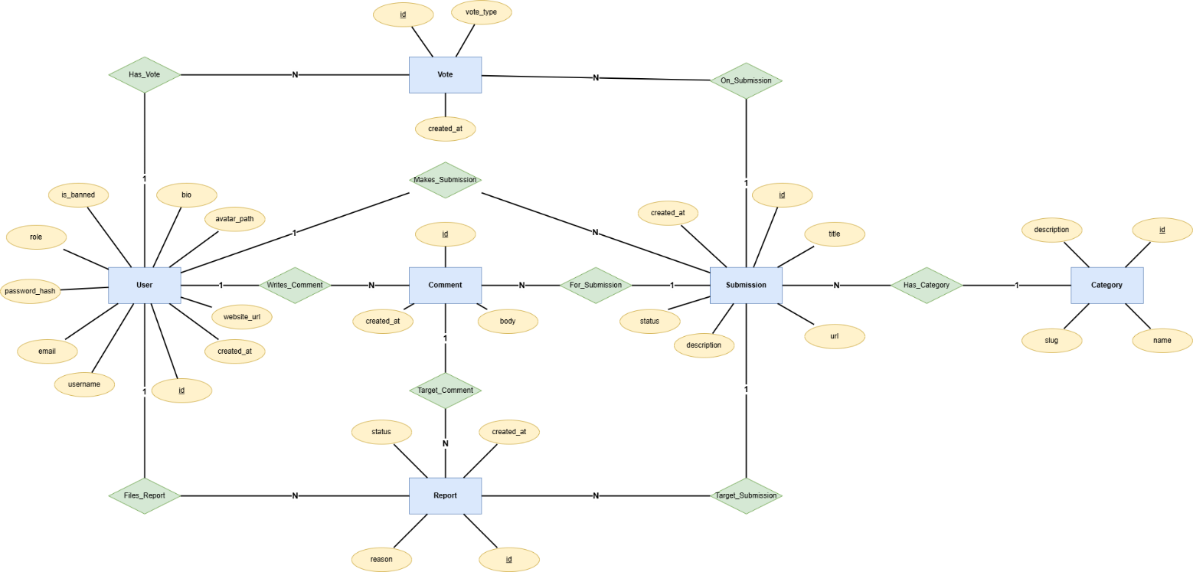
The database of UPPP is composed of six (6) entities: users, categories, links, votes, comments, and reports. The diagram below illustrates the relationships among these entities.

The following describes the relationships between the entities:
- A USER can submit many SUBMISSIONS (one-to-many). Each submission belongs to exactly one user.
- A SUBMISSION belongs to one CATEGORY. A category can have many submissions (one-to-many). A category cannot be deleted if submissions are assigned to it.
- A USER can cast one VOTE per submission (many-to-many relationship resolved through the votes table). Each vote record stores either an upvote (+1) or a downvote (-1).
- A USER can post many COMMENTS on a submission (one-to-many). Each comment belongs to one user and one submission.
- A USER can file many REPORTS. Each report targets either a submission or a comment, but never at the same time. This is enforced by a CHECK constraint in the database.
Data Schema
The following is the complete SQL schema used to create the UPPP database. The database is configured to use the utf8mb4 character set and utf8mb4_unicode_ci collation to ensure support for a wide range of characters.

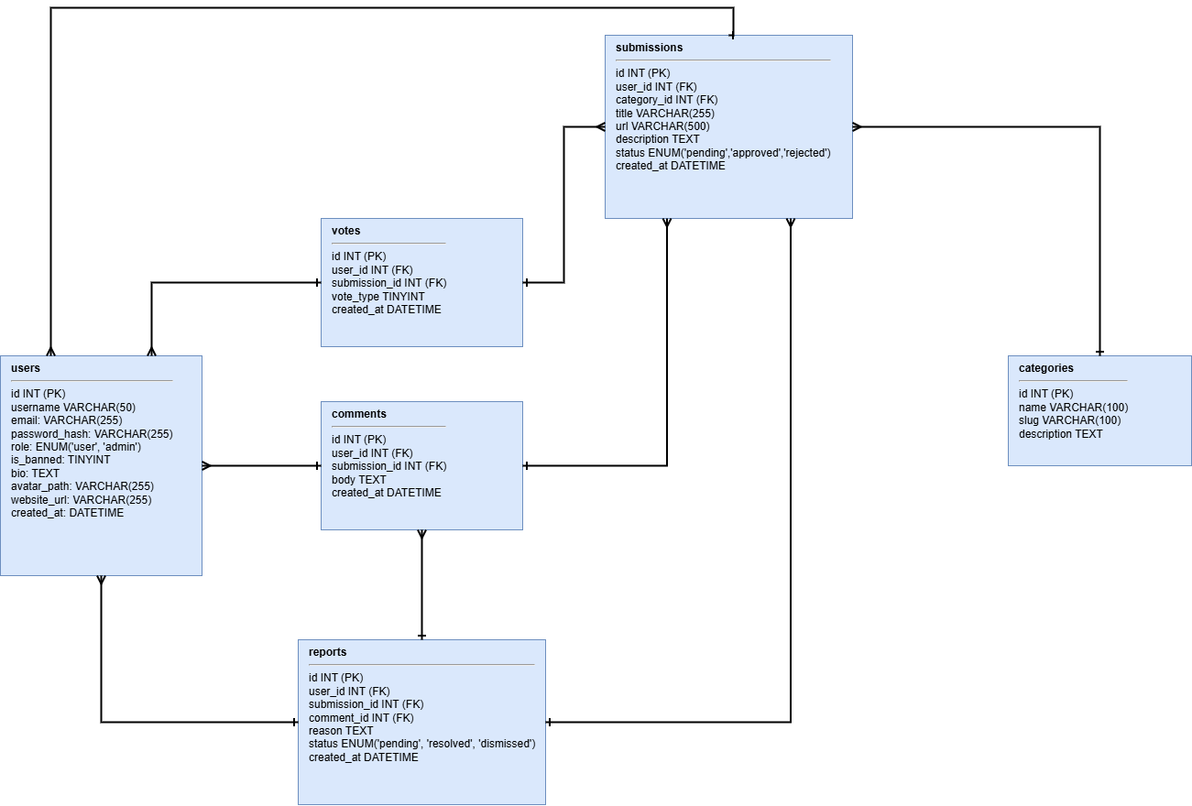
Database Dictionary
Table: Users
Field Name | Data Type | Size | Description | Key Type
id | INT | - | Unique identifier for each user | PK
username | VARCHAR | 50 | User's chosen display name | Unique
email | VARCHAR | 255 | User's email address | Unique
password_hash | VARCHAR | 255 | Hashed password for user authentication
role | ENUM | - | Role of the user ('user' or 'admin')
is_banned | TINYINT | 1 | Status if the user is banned (0=no,1=yes)
bio | TEXT | - | User biography
avatar_path | VARCHAR | 255 | Path to user's profile image
website_url | VARCHAR | 255 | User's personal website URL
created_at | DATETIME | - | Account creation timestamp

Table: Submissions
Field Name | Data Type | Size | Description | Key Type
id | INT | 11 | Unique identifier for each link submission | PK
user_id | INT | 11 | ID of user who submitted the link | FK
category_id | INT | - | ID of the category the submission belongs to | FK
title | VARCHAR | 255 | Title of the link
url | VARCHAR | 500 | URL of the link
description | TEXT | - | Short description of link
status | ENUM | - | Submission status (pending/approved/rejected)
created_at | DATETIME | - | Submission timestamp

Table: Categories
Field Name | Data Type | Size | Description | Key Type
id | INT | 11 | Unique identifier for each category | PK
name | VARCHAR | 50 | Name of the category | Unique
slug | VARCHAR | 100 | URL-friendly version of the category name | Unique
description | TEXT | - | Optional description of the category

Table: Votes
Field Name | Data Type | Size | Description | Key Type
id | INT | - | Unique identifier for each vote | PK
user_id | INT | - | ID of user who cast the vote | FK
submission_id | INT | - | ID of the submission being voted on | FK
vote_type | TINYINT | 1 | +1 for upvote, -1 for downvote
created_at | DATETIME | - | Timestamp of when the vote was cast

Table: Comments
Field Name | Data Type | Size | Description | Key Type
id | INT | - | Unique identifier for each comment | PK
user_id | INT | - | ID of user who posted the comment | FK
submission_id | INT | - | ID of the submission the comment belongs to | FK
body | TEXT | - | Content of the comment
Created_at | DATETIME | - | Timestamp when the comment was posted

Table: Reports
Field Name | Data Type | Size | Description | Key Type
id | INT | - | Unique identifier for each report | PK
user_id | INT | - | ID of the user who filed the report | FK
submission_id | INT | - | ID of the reported submission (nullable) | FK
comment_id | INT | - | ID of the reported comment (nullable) | FK
reason | TEXT | - | Reason for filing the report
status | ENUM | - | Status of report ('pending','resolved','dismissed')
created_at | DATETIME | - | Timestamp when the report was created

Chapter III
CRUD Implementation
This chapter presents the CRUD (Create, Read, Update, Delete) operations implemented in the UPPP system. Each operation is demonstrated using actual PHP code from the project files, followed by an explanation of how the operation works.
Create
- User Registration (register.php)
When a new user fills out the registration form and submits it, the system validates the input and inserts a new record into the users table. The password is never stored in plain text; instead, it is hashed using PHP’s built-in password_hash() function before being saved.

// Collect and trim input
$username = trim($_POST['username'] ?? '');
$email = trim($_POST['email'] ?? '');
$password = $_POST['password'] ?? '';
$confirm = $_POST['confirm'] ?? '';

// Validation
if (strlen($username) < 3 || strlen($username) > 50)
$errors[] = 'Username must be 3–50 characters.';
if (!filter_var($email, FILTER_VALIDATE_EMAIL))
$errors[] = 'Please enter a valid email address.';
if (strlen($password) < 6)
$errors[] = 'Password must be at least 6 characters.';
if ($password !== $confirm)
$errors[] = 'Passwords do not match.';

// Check for duplicate username or email
$stmt = $pdo->prepare(
'SELECT id FROM users WHERE username = ? OR email = ?'
);
$stmt->execute([$username, $email]);
if ($stmt->fetch()) $errors[] = 'Username or email already taken.';

// If no errors, insert new user
if (empty($errors)) {
$hash = password_hash($password, PASSWORD_DEFAULT);
$stmt = $pdo->prepare(
'INSERT INTO users (username, email, password_hash)
VALUES (?, ?, ?)'
);
$stmt->execute([$username, $email, $hash]);
login_user($pdo, $email, $password);
redirect('index.php');
}
The code above demonstrates how the system collects user input, validates each field, checks for duplicate accounts, and inserts a new user record with a hashed password. After successful registration, the user is automatically logged in and redirected to the homepage.
2. Link Submission (submit.php)
Authenticated users can submit a new link by filling out the submission form. The system validates all fields and checks if the URL has already been approved before inserting the record with a pending status.

// Collect input
$title = trim($_POST['title'] ?? '');
$url = trim($_POST['url'] ?? '');
$description = trim($_POST['description'] ?? '');
$category_id = (int)($_POST['category_id'] ?? 0);
// Validate
if (strlen($title) < 3 || strlen($title) > 255)
$errors[] = 'Title must be 3–255 characters.';
if (!filter_var($url, FILTER_VALIDATE_URL) || strlen($url) > 500)
$errors[] = 'Please enter a valid URL (max 500 characters).';
if (strlen($description) < 10)
$errors[] = 'Description must be at least 10 characters.';
if ($category_id <= 0)
$errors[] = 'Please select a category.';
// Check for duplicate approved URL
$stmt = $pdo->prepare(
'SELECT id FROM submissions WHERE url = ? AND status = ?'
);
$stmt->execute([$url, 'approved']);
if ($stmt->fetch()) $errors[] = 'This URL has already been submitted.';
// Insert with pending status
if (empty($errors)) {
$stmt = $pdo->prepare(
'INSERT INTO submissions
(user_id, category_id, title, url, description)
VALUES (?, ?, ?, ?, ?)'
);
$stmt->execute([
current_user_id(), $category_id, $title, $url, $description
]);
flash('success', 'Submission received! Pending review.');
redirect('index.php');
}
New submissions are saved with a pending status and become publicly visible only after administrator approval.
Read (Display)
- Homepage with Top of the Week Ranking (index.php)
The homepage displays the Top of the Week submissions and the most recent approved submissions. Rankings are based on vote score and recency.

// Top of the Week: approved submissions from the past 7 days
// ranked by votes + recency bonus
$topSql = '
SELECT
s.*,
u.username,
c.name AS category_name,
COALESCE(SUM(v.vote_type), 0) AS net_votes,
COALESCE(SUM(v.vote_type), 0)
+ GREATEST(0, 7 - DATEDIFF(NOW(), s.created_at)) AS rank_score,
(SELECT COUNT(*) FROM comments cm
WHERE cm.submission_id = s.id) AS comment_count
FROM submissions s
JOIN users u ON s.user_id = u.id
JOIN categories c ON s.category_id = c.id
LEFT JOIN votes v ON v.submission_id = s.id
WHERE s.status = ? AND s.created_at >= NOW() - INTERVAL 7 DAY
GROUP BY s.id
ORDER BY rank_score DESC
LIMIT 5
';
$stmt = $pdo->prepare($topSql);
$stmt->execute(['approved']);
$topSubmissions = $stmt->fetchAll();
This query retrieves submission data along with user and category details. It calculates vote scores and applies a recency-based ranking formula.
2. Search (search.php)
Users can search for submissions using keywords across titles, descriptions, and URLs.

$q = trim($_GET['q'] ?? '');
$term = '%' . escape_like($q) . '%';
$countSql = 'SELECT COUNT(*) FROM submissions s
JOIN users u ON s.user_id = u.id
WHERE s.status = ? AND (
s.title LIKE ? OR
s.description LIKE ? OR
s.url LIKE ?
)';
$pagination = paginate($pdo, $countSql,
['approved', $term, $term, $term]);
$stmt = $pdo->prepare(
'SELECT s.*, u.username, c.name AS category_name
FROM submissions s
JOIN users u ON s.user_id = u.id
JOIN categories c ON s.category_id = c.id
WHERE s.status = ? AND (
s.title LIKE ? OR s.description LIKE ? OR s.url LIKE ?
)
ORDER BY s.created_at DESC
LIMIT :limit OFFSET :offset'
);
$stmt->execute(['approved', $term, $term, $term]);
$results = $stmt->fetchAll();
This ensures that each user has only one vote per submission and allows toggling between vote states.

Update (Edit)
1. Vote Toggle (vote.php)
The voting system allows users to insert, remove, or update votes dynamically.
// Check if user already voted on this submission
$stmt = $pdo->prepare(
'SELECT vote_type FROM votes
WHERE user_id = ? AND submission_id = ?'
);
$stmt->execute([$userId, $submissionId]);
$existing = $stmt->fetchColumn();
if ($existing === false) {
// No existing vote — insert
$stmt = $pdo->prepare(
'INSERT INTO votes (user_id, submission_id, vote_type)
VALUES (?, ?, ?)'
);
$stmt->execute([$userId, $submissionId, $voteType]);
} elseif ((int)$existing === $voteType) {
// Same vote clicked again — delete (toggle off)
$stmt = $pdo->prepare(
'DELETE FROM votes
WHERE user_id = ? AND submission_id = ?'
);
$stmt->execute([$userId, $submissionId]);
} else {
// Opposite vote — update
$stmt = $pdo->prepare(
'UPDATE votes SET vote_type = ?
WHERE user_id = ? AND submission_id = ?'
);
$stmt->execute([$voteType, $userId, $submissionId]);
}
// Return updated score as JSON
header('Content-Type: application/json');
echo json_encode(['score' => get_vote_score($pdo, $submissionId)]);
This ensures that each user has only one vote per submission and allows toggling between vote states.
2. Admin: Approve or Reject a Submission (admin/submissions.php)
Administrators can change the status of a pending submission to either 'approved' or 'rejected'. The action is performed through a form submission using the POST method with CSRF verification.

if ($_SERVER['REQUEST_METHOD'] === 'POST' && verify_csrf()) {
$subId = (int)($_POST['submission_id'] ?? 0);
$action = $_POST['action'] ?? '';
if ($subId > 0 && in_array($action, ['approved', 'rejected'])) {
$stmt = $pdo->prepare(
'UPDATE submissions SET status = ? WHERE id = ?'
);
$stmt->execute([$action, $subId]);
flash('success', 'Submission ' . $action . '.');
}
redirect('submissions.php?status=' . ($_GET['status'] ?? 'pending'));
}
The in_array() function ensures that only the allowed status values (approved or rejected) can be set. This prevents unauthorized or invalid input even if the form is bypassed. Additionally, the CSRF token is verified before any database modification is performed, ensuring protection against Cross-Site Request Forgery attacks.

Delete (Remove)
Comment Deletion (submission.php)
Users are allowed to delete their own comments, while administrators have the authority to delete any comment. Before deletion, the system verifies whether the currently logged-in user is the owner of the comment or an administrator.

if (isset($_GET['delete_comment'])) {
require_login();
$commentId = (int)$_GET['delete_comment'];
// Fetch the comment record
$stmt = $pdo->prepare('SELECT * FROM comments WHERE id = ?');
$stmt->execute([$commentId]);
$comment = $stmt->fetch();
// Check authorization: must be comment owner or admin
if ($comment && (
current_user_id() === (int)$comment['user_id'] || is_admin()
)) {
$stmt = $pdo->prepare('DELETE FROM comments WHERE id = ?');
$stmt->execute([$commentId]);
flash('success', 'Comment deleted.');
}
redirect('submission.php?id=' . $id);
}
The deletion process only proceeds if the comment exists, and the authorization check is satisfied. After deletion, the user is redirected back to the same submission page with a success message. Since the database uses ON DELETE CASCADE, any related reports associated with the deleted comment are automatically removed.
Security Measures
Input Validation
All user inputs are validated on the server side before processing. PHP built-in functions are used to ensure correct data types and formats.

// Length checks
if (strlen($username) < 3 || strlen($username) > 50) ...

// Email format
if (!filter_var($email, FILTER_VALIDATE_EMAIL)) ...
// URL format
if (!filter_var($url, FILTER_VALIDATE_URL)) ...
// Integer cast for IDs (prevents SQL injection through type mismatch)
$id = (int)($_GET['id'] ?? 0);
if ($id <= 0) { redirect('index.php'); }
Prepared Statements
All database queries in the UPPP system use PDO prepared statements. This ensures that user input is never directly embedded into SQL queries, significantly reducing the risk of SQL injection attacks.

// UNSAFE (never done in uppp):
// $pdo->query("SELECT * FROM users WHERE email = '$email'");
// SAFE (always done this way):
$stmt = $pdo->prepare('SELECT * FROM users WHERE email = ?');
$stmt->execute([$email]);
$user = $stmt->fetch();
The PDO connection is configured with emulated prepares disabled (PDO::ATTR_EMULATE_PREPARES = false), ensuring that real prepared statements are executed at the database level.
Error Handling
PDO is configured to throw exceptions on errors (PDO::ERRMODE_EXCEPTION), allowing efficient detection and handling of issues during development. All output displayed to users is sanitized to prevent Cross-Site Scripting (XSS) attacks.

// sanitize() in includes/functions.php
function sanitize(string $value): string {
return htmlspecialchars(trim($value), ENT_QUOTES, 'UTF-8');
}
// Usage in views:
echo sanitize($submission['title']);
echo sanitize($user['username']);
Additionally, all state-changing forms include a CSRF token that is verified on the server before processing. This prevents Cross-Site Request Forgery (CSRF) attacks, ensuring that only legitimate requests are executed.

Chapter IV.
USER MANUAL
This chapter provides a step-by-step guide on how to use the UPPP system. The manual covers both regular user and administrator functions. Screenshots should be inserted at the designated areas.
Step 1: Accessing the Homepage
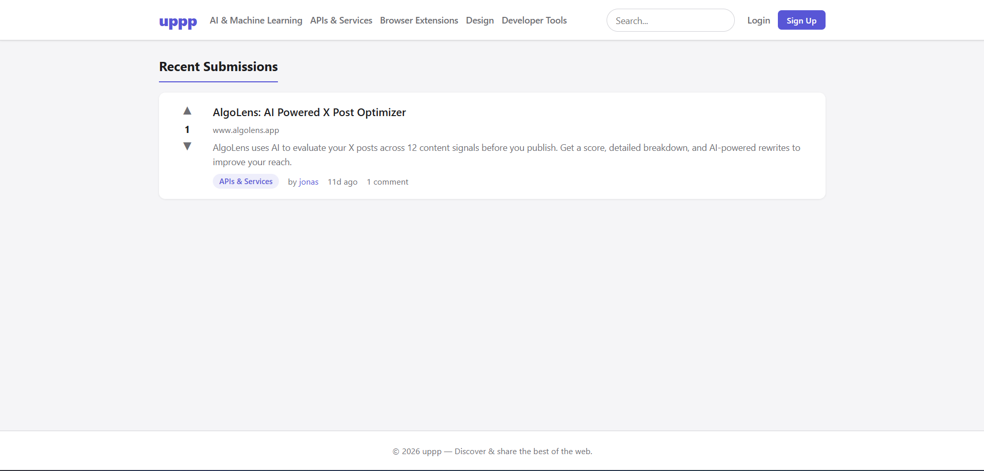
Open a web browser and go to http://localhost/uppp/. The homepage displays the Top of the Week section at the top, which shows the five highest-ranked submissions from the past seven days. Below it, the most recently approved submissions are listed with pagination controls at the bottom.

Step 2: Registering an Account
Click the Sign-Up link in the top navigation bar. Fill out the registration form by entering a username (3–50 characters), a valid email address, and a password (minimum of 6 characters). Enter the password again in the Confirm Password field, then click the Register button.
If all inputs are valid and the username and email are not already taken, the account is created, and the user is automatically logged in.
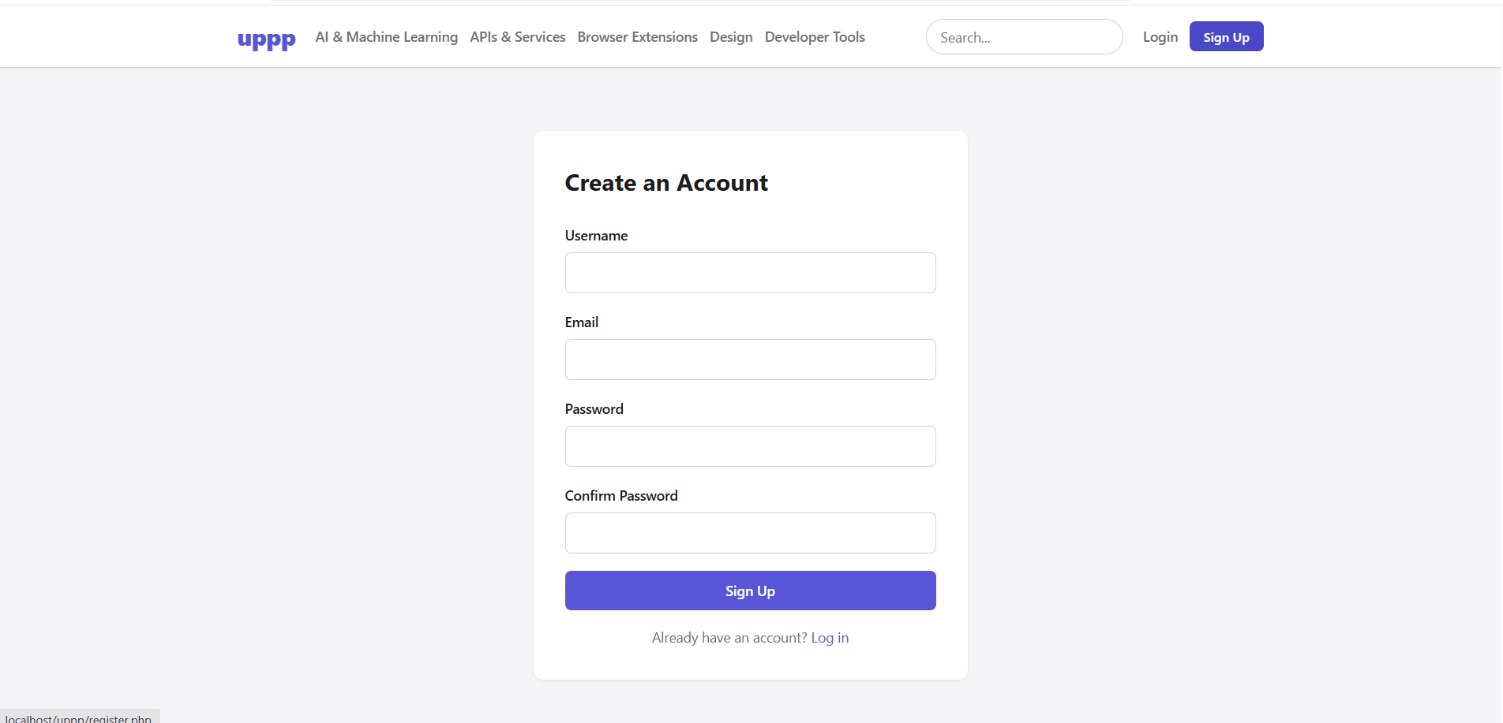Step 3: Logging In
Click the Login link in the navigation bar. Enter the registered email address and password, then click the Login button.
If the credentials are correct and the account is not banned, the user is redirected to the homepage with a success message. If the login fails, an error message is displayed without specifying which field is incorrect.
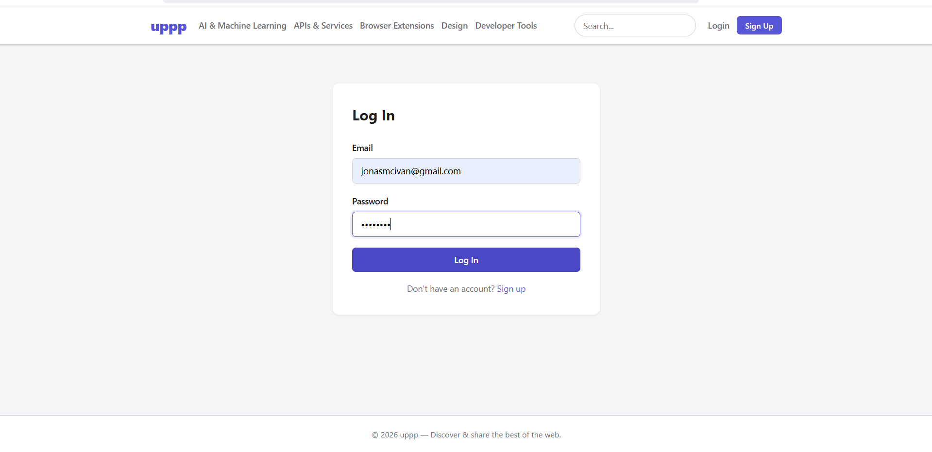
Step 4: Submitting a Link
After logging in, click the Submit link in the navigation bar. Fill out the submission form with a title (3–255 characters), the URL, a description of at least 10 characters, and a category. Click Submit.
The link is saved with a pending status and will only appear publicly after administrator approval. A confirmation message will be displayed.
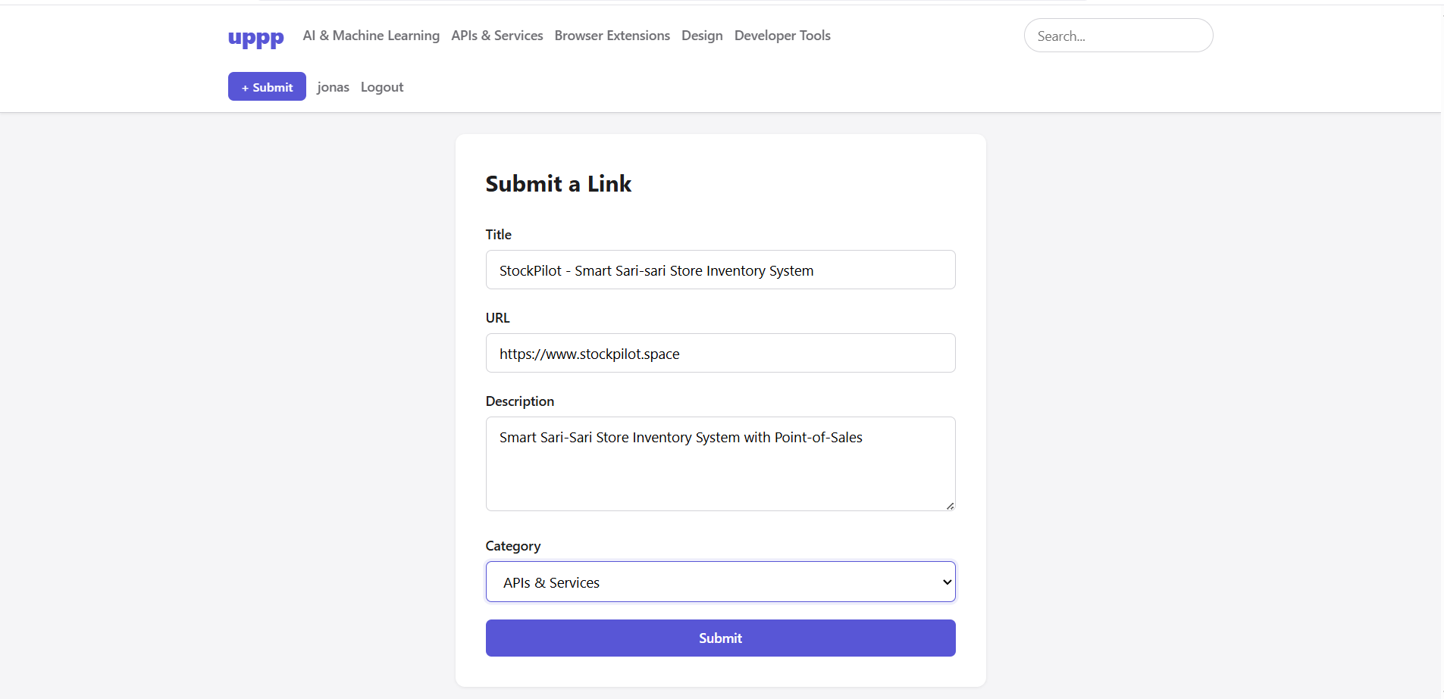

Step 5: Voting on a Submission
On the homepage or any submission list, click the upvote (▲) or downvote (▼) button beside a submission. The vote score updates instantly without reloading the page.
Clicking the same vote again removes it, while clicking the opposite vote switches it. Users must be logged in to vote.
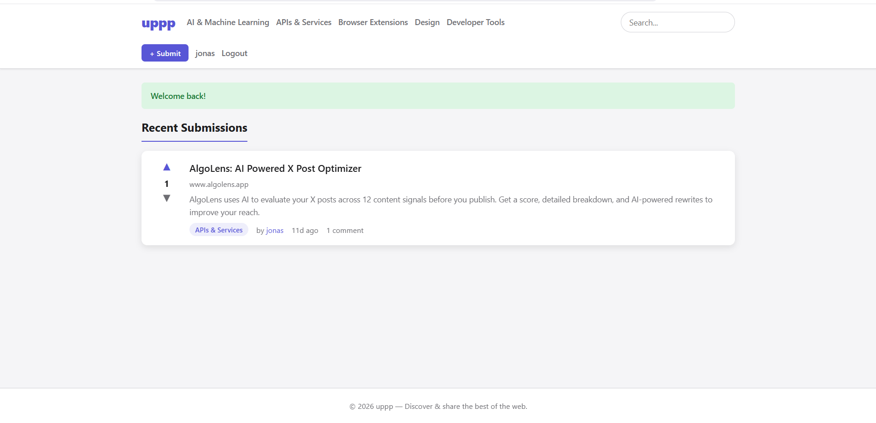
Step 6: Viewing and Leaving a Comment
Click the title of any approved submission to open its detail page. The full description, vote score, and comment section will be displayed.
To leave a comment, type in the text area and click Post Comment. The comment will appear immediately.
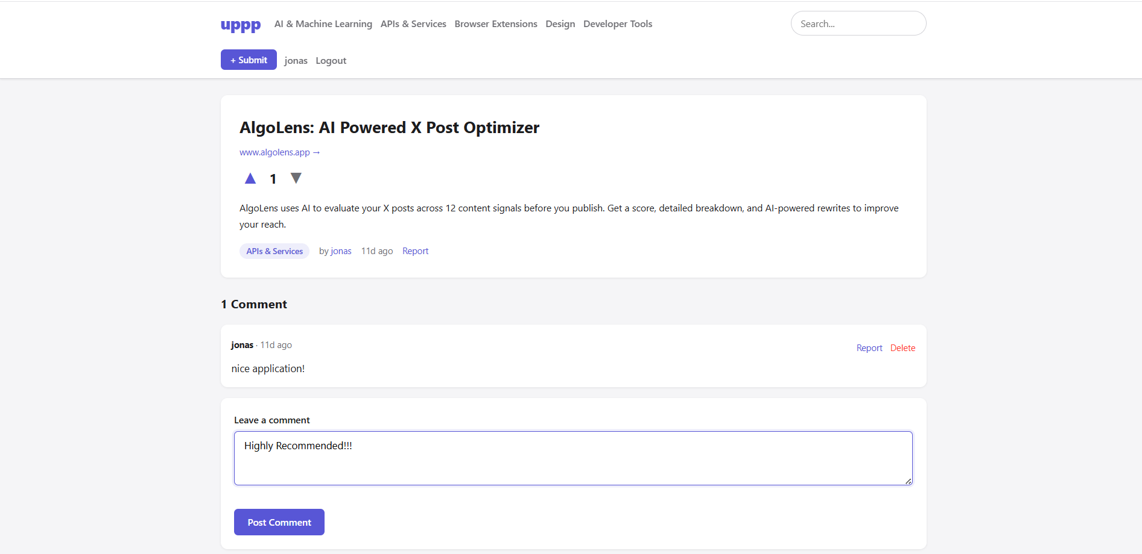

Step 7: Searching for Content
Click the search bar in the navigation bar and enter a keyword. Press Enter or click the search button.
The system displays approved submissions whose title, description, or URL matches the keyword. Results are paginated if necessary.
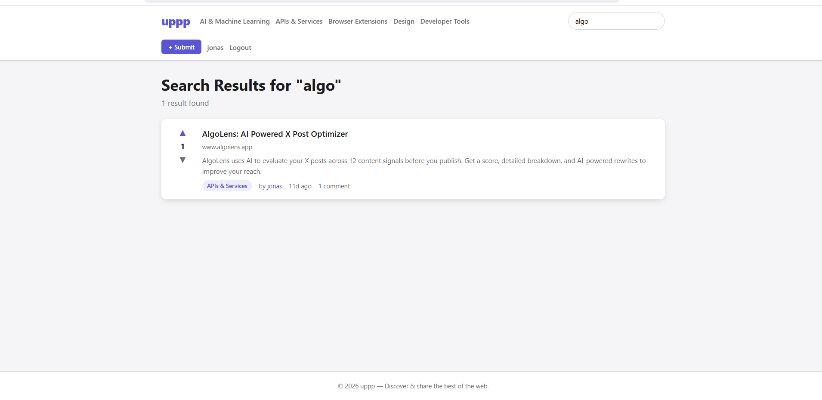
Step 8: Browsing by Category
Click any category name in the navigation bar. The category page displays all approved submissions under that category, sorted by newest first, with pagination.
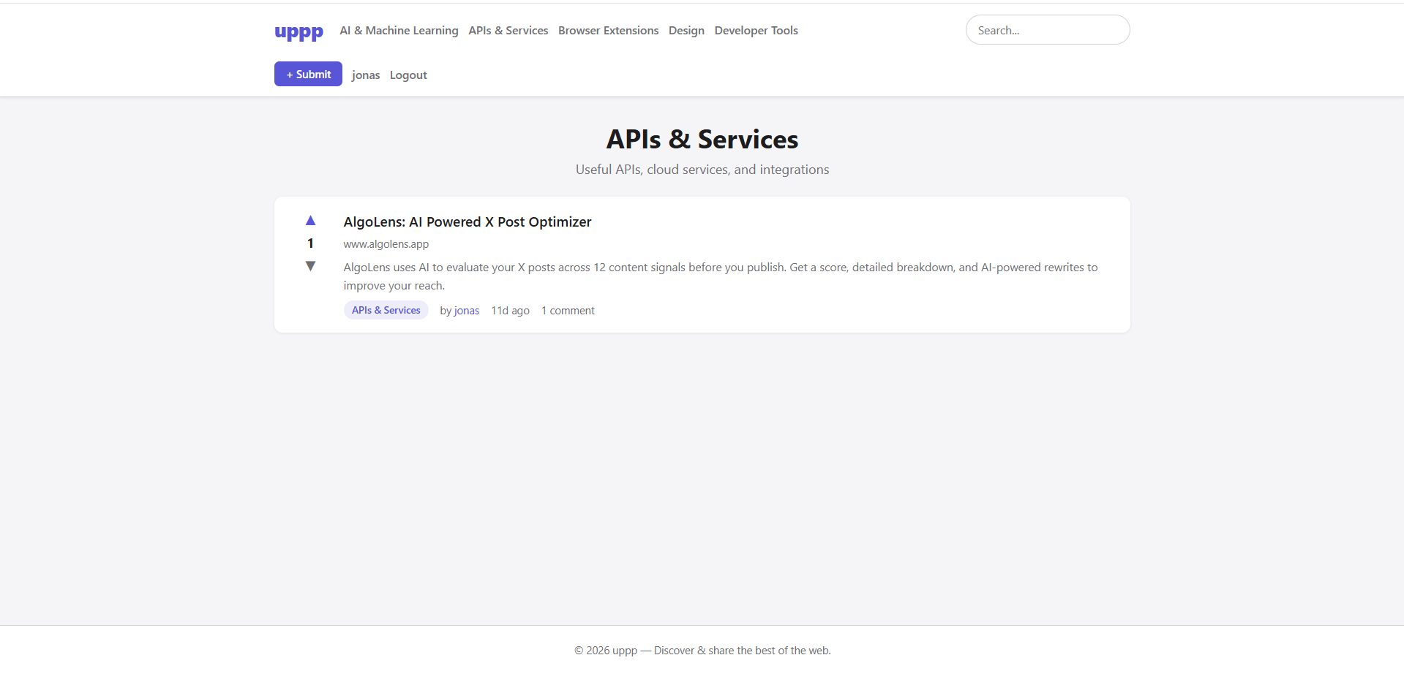
Step 9: Editing a Profile
Click the username in the navigation bar, then select Edit Profile. Users can update their bio and website URL.
To upload an avatar, click Choose File and select an image (JPG, PNG, or GIF, maximum 2MB), then click Save Changes. The avatar is automatically resized and updated.
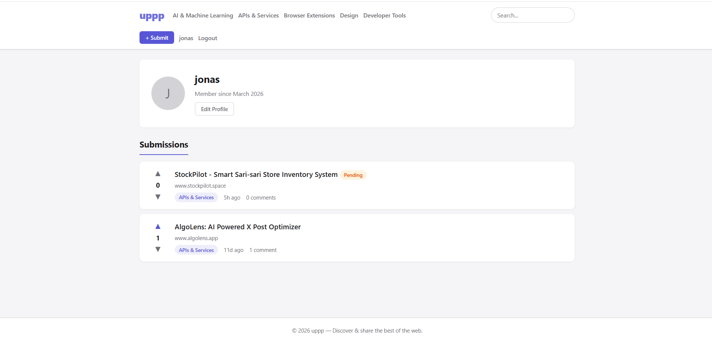
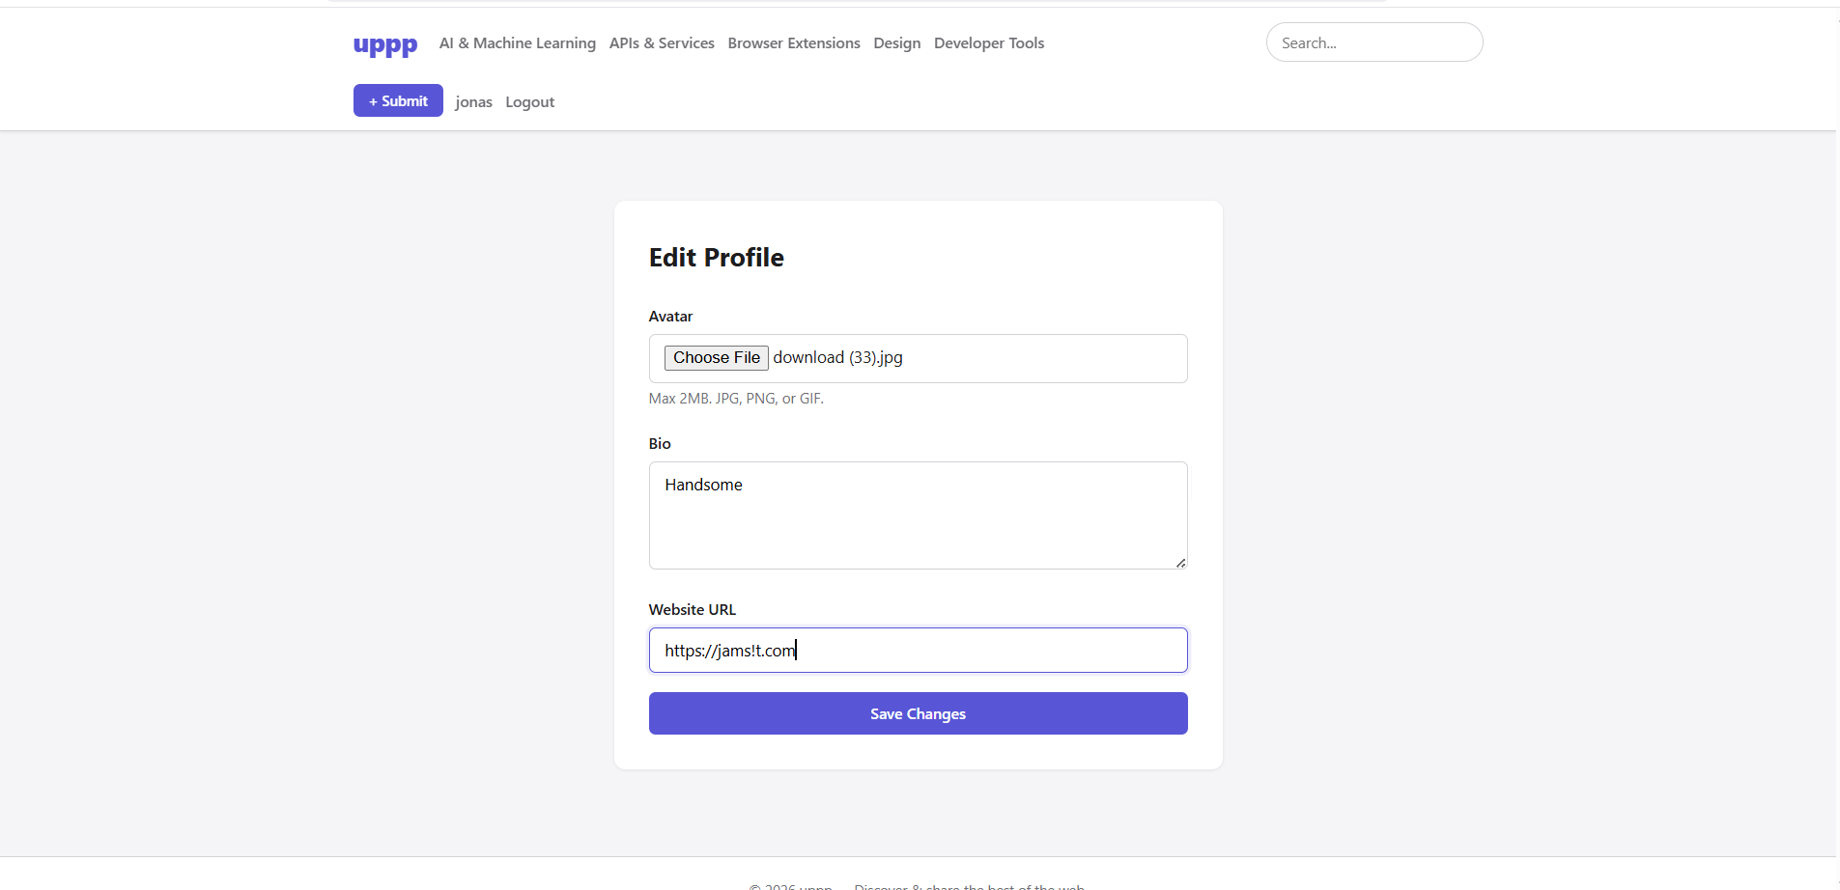

Step 10: Reporting Content
On a submission or comment, click the Report link. Enter the reason for the report and submit the form.
Reports are sent to the administrator for review. Users must be logged in to submit a report.
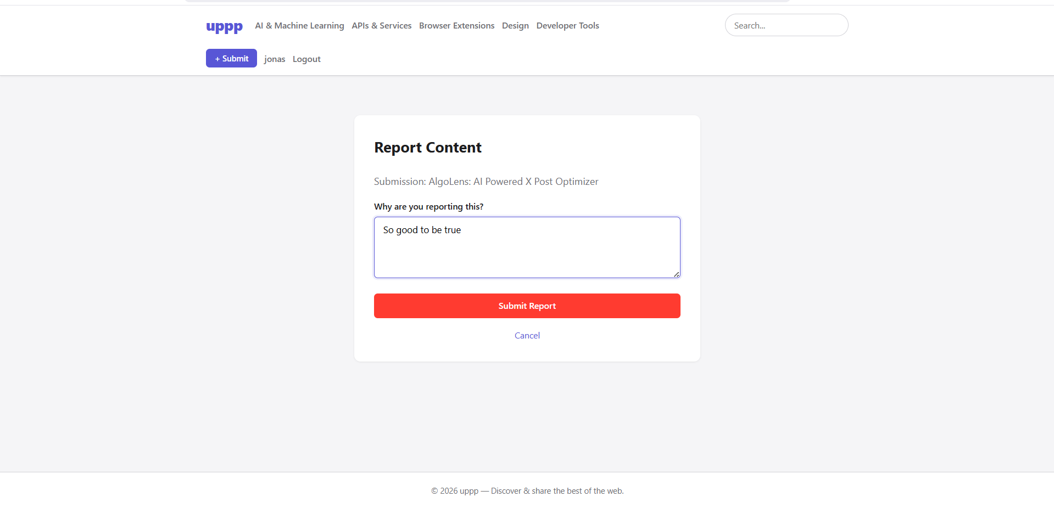
Step 11: Admin — Logging In as Administrator
Log in using the administrator credentials (default: email admin@uppp.local, password password).
After logging in, an Admin link appears in the navigation bar. Click it to access the admin dashboard.
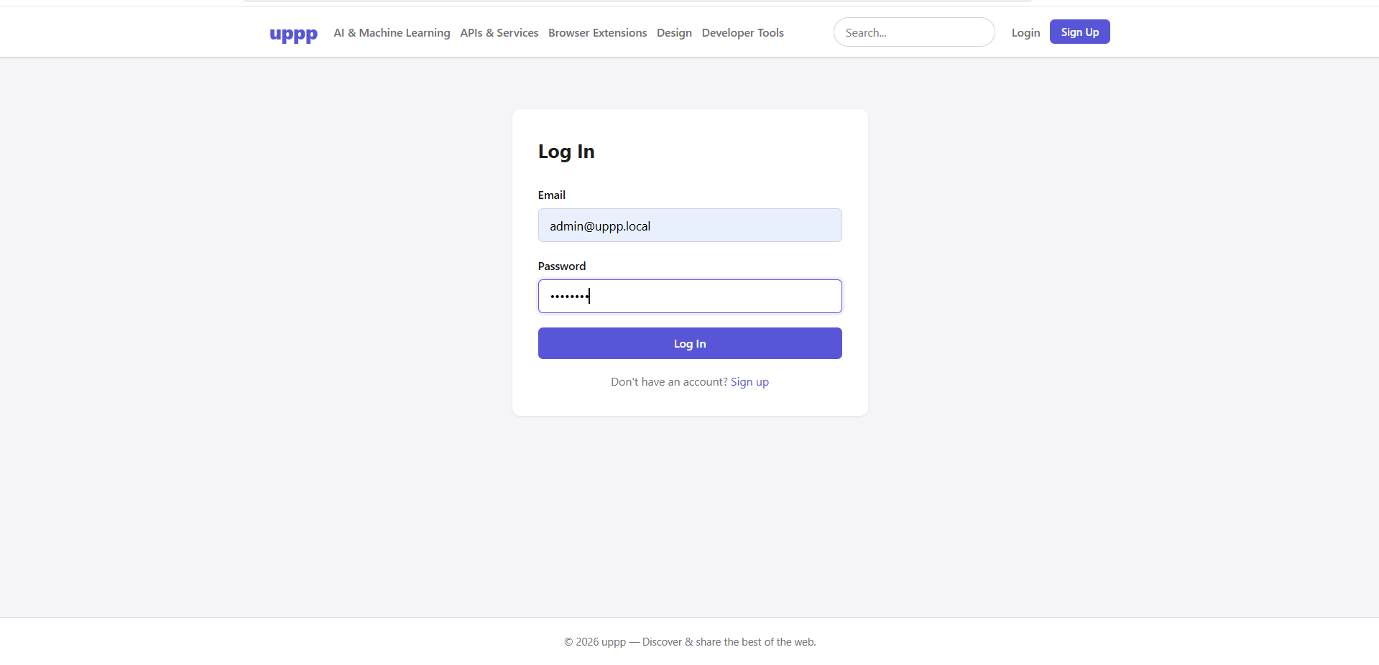
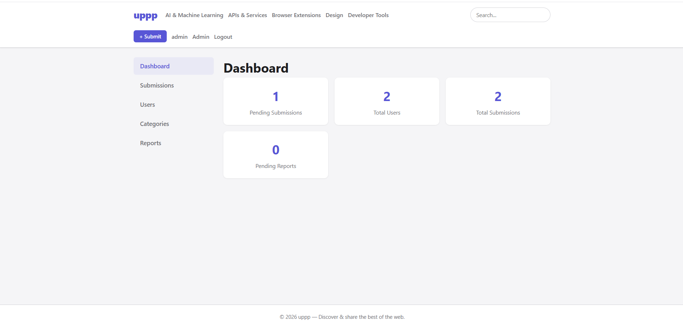
Step 12: Admin — Approving or Rejecting Submissions
In the admin panel, click Submissions. Pending submissions are displayed by default.
Review each submission and click Approve to make it public or Reject to hide it.
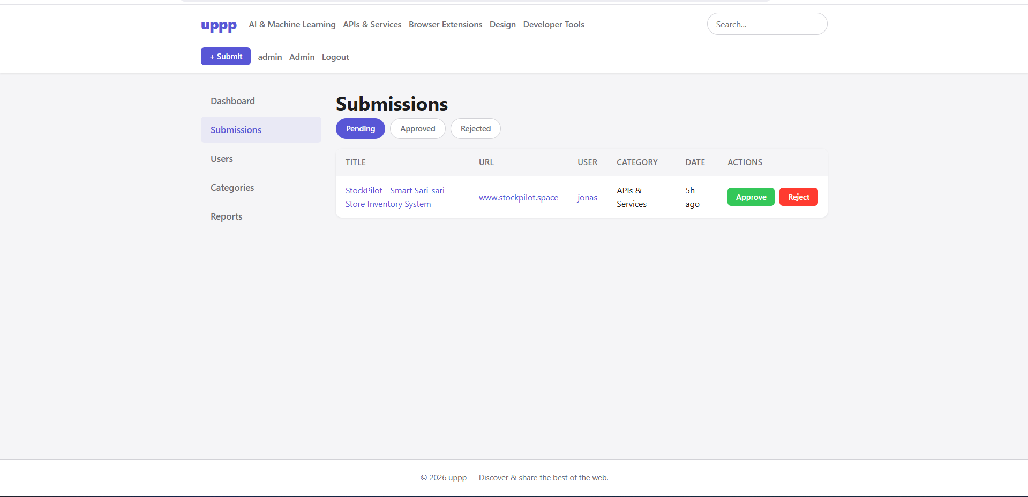
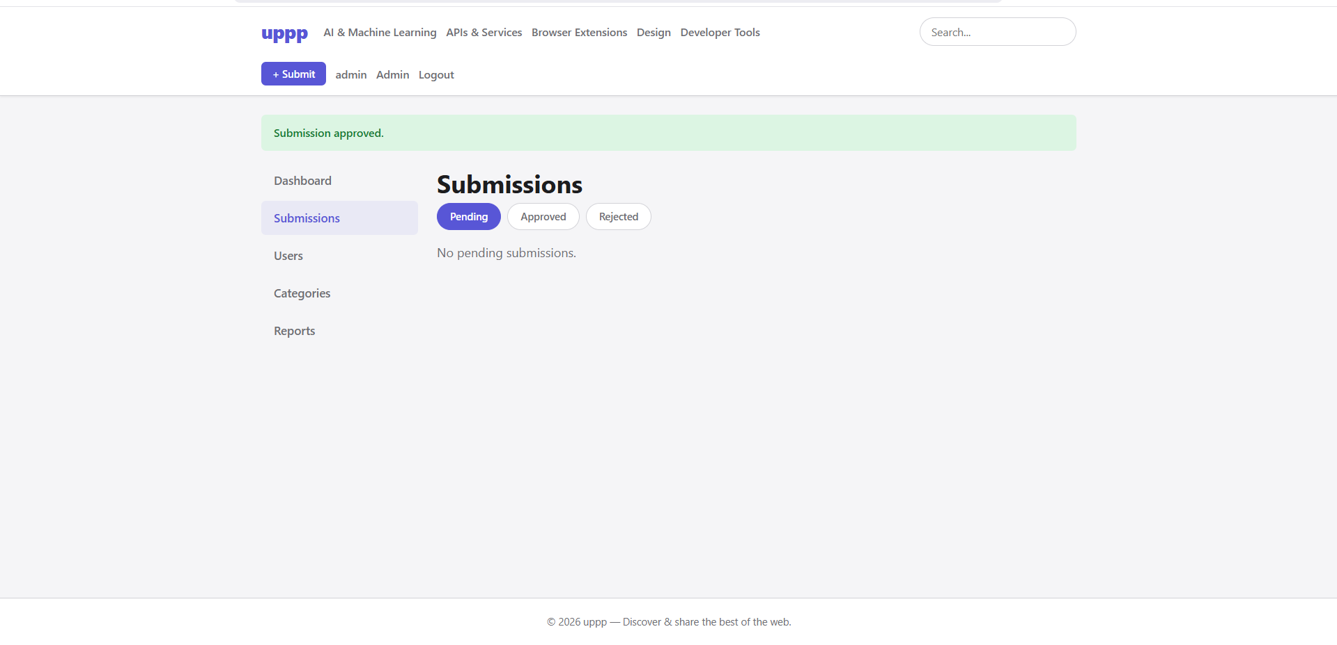
Step 13: Admin — Managing Users
Click Users in the admin sidebar to view all accounts.
Administrators can ban/unban users, promote users to admin, or demote admins to regular users.
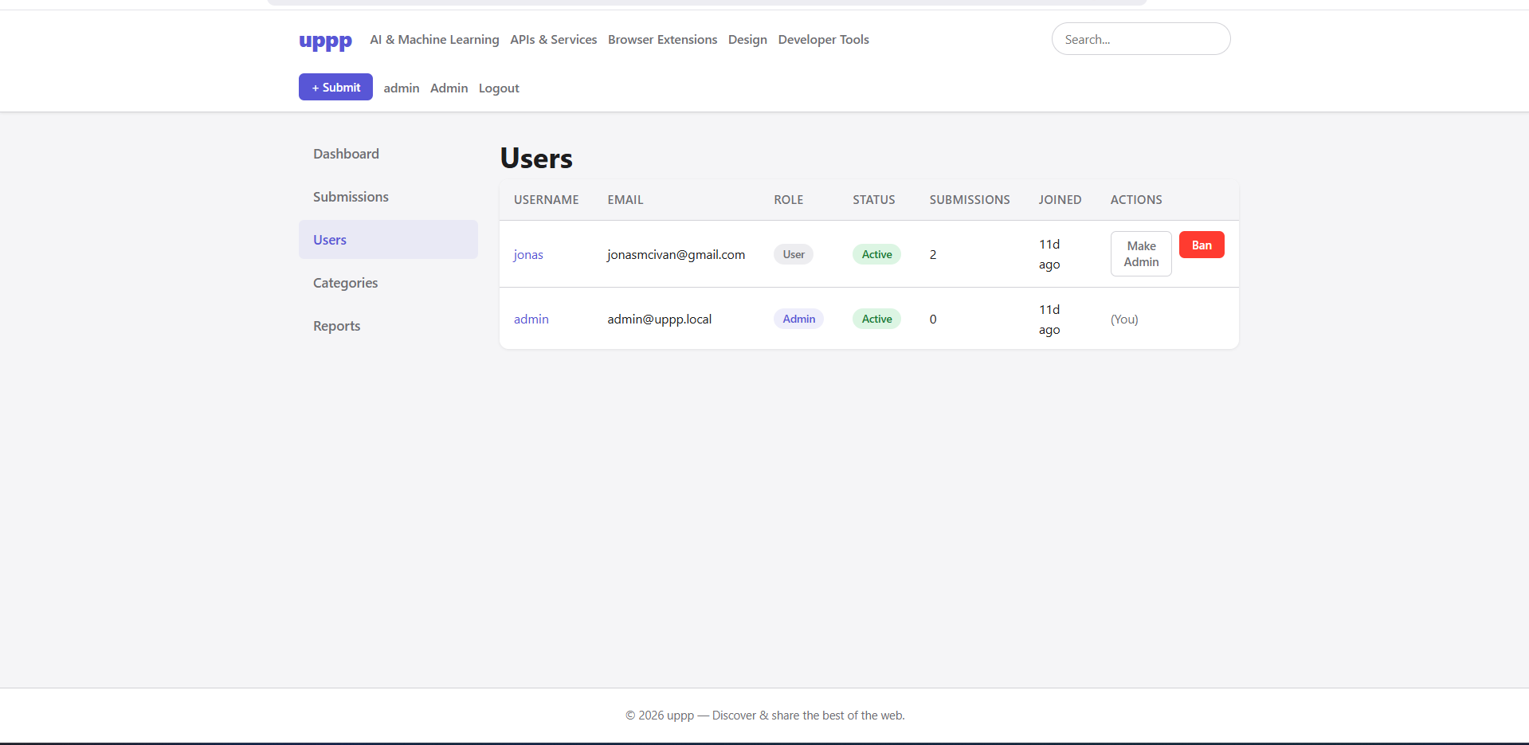
Step 14: Admin — Resolving Reports
Click Reports in the admin sidebar to view all reports.
Each report includes the reporter, content type, and reason. Administrators can mark reports as Resolved or Dismissed.
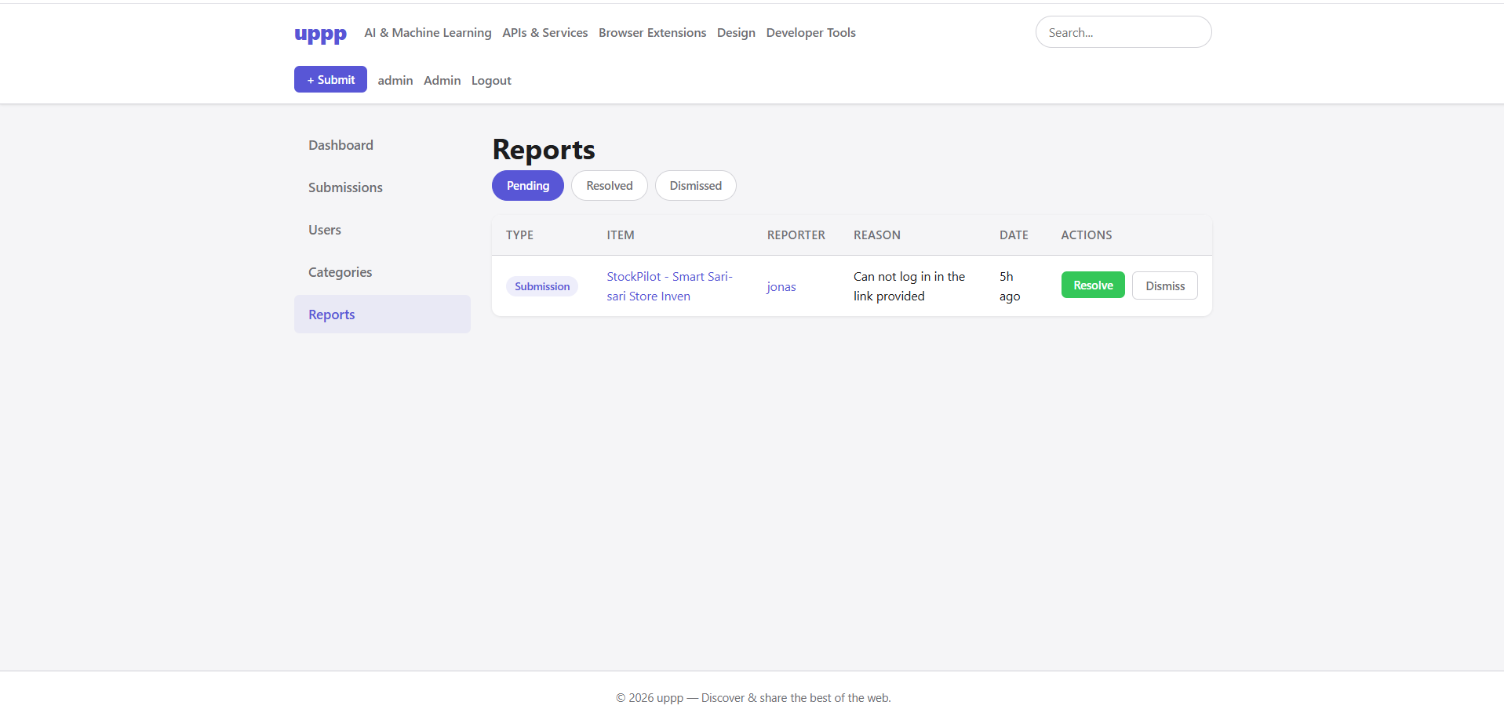

Step 15: Admin — Managing Categories
Click Categories in the admin sidebar to manage categories.
To add a category, enter the name and optional description, then click Add Category.
A category cannot be deleted if it has existing submissions.
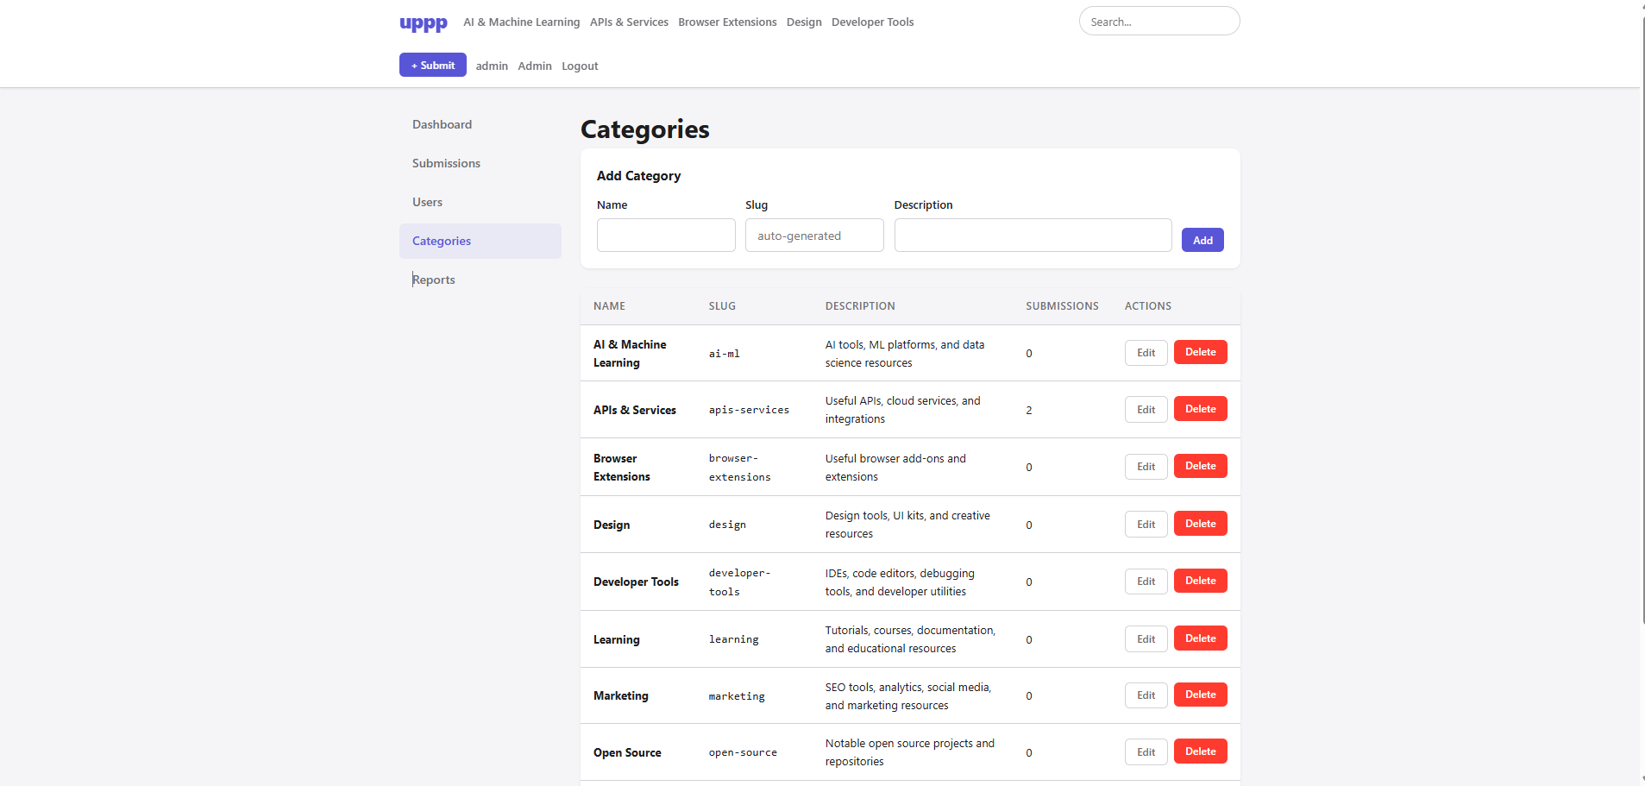
REFERENCES

Gilmore, W. J. (2010). Beginning PHP and MySQL: From novice to professional (4th ed.). Apress.
Kroenke, D. M., & Auer, D. J. (2015). Database concepts (7th ed.). Pearson Education.
MySQL AB. (2023). MySQL 8.0 reference manual. Oracle Corporation. https://dev.mysql.com/doc/refman/8.0/en/
The PHP Group. (2024). PHP: Hypertext preprocessor documentation. https://www.php.net/manual/en/
The PHP Group. (2024). PHP data objects (PDO). https://www.php.net/manual/en/book.pdo.php
OWASP Foundation. (2021). OWASP top ten. Open Web Application Security Project. https://owasp.org/www-project-top-ten/
OWASP Foundation. (2023). Cross-site request forgery (CSRF) prevention cheat sheet. https://cheatsheetseries.owasp.org/cheatsheets/Cross-Site_Request_Forgery_Prevention_Cheat_Sheet.html
OWASP Foundation. (2023). SQL injection prevention cheat sheet. https://cheatsheetseries.owasp.org/cheatsheets/SQL_Injection_Prevention_Cheat_Sheet.html
Apache Friends. (2024). XAMPP — Apache + MariaDB + PHP + Perl. https://www.apachefriends.org/
Codd, E. F. (1970). A relational model of data for large shared data banks. Communications of the ACM, 13(6), 377–387. https://doi.org/10.1145/362384.362685

